|  |  |
| --- | --- |
| Ex.no.3 | **PASS TWO OF TWO PASS ASSEMBLER** |
| 17.10.20 |

### Head

#include <stdio.h>

#include <string.h>

#include <stdlib.h>

FILE *fp2,*fp1;

typedef struct InputRec{

char label[10];

char opcode[10];

char opr1[10];

char opr2[10];

char address[5];

}InputRec;

typedef struct Symtab{

char name[10];

char type[2];

char address[5];

}

Symtab;

typedef struct OutRec{

char label[10];

char opcode[10];

char opr1[10];

char opr2[10];

char address[5];

char machinecode[7];

}OutRec;

typedef struct Optab{

char opcode[10];

char machinecode[3];

}Optab;

typedef struct HeadRec{

char pgmname[10];

char address[5];

char pgmlength[3];

}HeadRec;

typedef struct TextRec{

char startaddress[5];

char length[3];

char objcode[7];

}TextRec;

void objectCodeGeneration(char[],char[],Symtab[],Optab[],int,int);

void objectProgramGeneration(char[],char[]);

Optab searchOptab(char[],Optab[],int);

Symtab searchSymtab(char[],Symtab[],int);

void display(char[]);

char findACII(char);

### Implementation

#include "head.h"

void objectCodeGeneration(char fname[],char fname1[],Symtab sys[],Optab opt[],int syscount,int opcount){

int len=0, j=0,i;

char value[10],temp[3],ch;

fp1=fopen(fname,"r");

fp2=fopen(fname1,"w");

OutRec out;

Optab o;

Symtab s;

InputRec in;

while(!feof(fp1)){

fread(&in,sizeof(in),1,fp1); if(strcmp(in.opcode,"START")==0||strcmp(in.opcode,"END")==0||strcmp(in.opcode,"RESB")==0||strcmp(in.opcode,"RESW")==0||strcmp(in.opcode,"EQU")==0){

strcpy(out.machinecode,"\0");

}

else if(strcmp(in.opcode,"BYTE")==0){

if(in.opr1[0]=='X'){

len=strlen(in.opr1);

j=0;

for(i=2;i<len-1;i++){

out.machinecode[j]=in.opr1[i];

j++;

}

out.machinecode[j]='\0';

}

else if(in.opr1[0]=='C'){

j=2;

len=strlen(in.opr1);

for(i=0;i<len-3;i++){

value[i]=in.opr1[j];

j++;

}

value[i]='\0';

len=strlen(value);

strcpy(out.machinecode,"\0");

i=0;

while(i<len){

sprintf(temp,"%02x",value[i]);

i++;

strcat(out.machinecode,temp);

}

}

}

else if(strcmp(in.opcode,"WORD")==0){

strcpy(out.machinecode,"000000");

len=strlen(in.opr1);

j=6-len;

for(i=0;i<len;i++){

out.machinecode[j]=in.opr1[i];

j++;

}

out.machinecode[6]='\0';

}

else{

o=searchOptab(in.opcode,opt,opcount);

if(strcmp(in.opr1,"\0")!=0){

s=searchSymtab(in.opr1,sys,syscount);

if(strcmp(in.opr2,"X")==0){

ch=s.address[0];

if(ch=='0')

s.address[0]='8';

else if (ch=='1')

s.address[0]='9';

else if (ch=='2')

s.address[0]='a';

else if (ch=='3')

s.address[0]='b';

else if (ch=='4')

s.address[0]='c';

else if (ch=='5')

s.address[0]='d';

else if (ch=='6')

s.address[0]='e';

else if (ch=='7')

s.address[0]='f';

}

strcpy(out.machinecode,o.machinecode);

strcat(out.machinecode,s.address);

}

}

strcpy(out.address,in.address);

strcpy(out.label,in.label);

strcpy(out.opcode,in.opcode);

strcpy(out.opr1,in.opr1);

strcpy(out.opr2,in.opr2);

fwrite(&out,sizeof(out),1,fp2);

}

fclose(fp1);

fclose(fp2);

printf("\nFile with machinecode\n\n");

display(fname1);

}

void objectProgramGeneration(char fname[],char fname1[]){

int count=0,first,las,pl,len;

char last[10];

HeadRec h;

OutRec out;

TextRec t;

fp1=fopen(fname,"r");

fp2=fopen(fname1,"w");

while(!feof(fp1)){

fread(&out,sizeof(out),1,fp1);

if(strcmp(out.opcode,"END")==0)

strcpy(last,out.address);

}

fclose(fp1);

fp1=fopen(fname,"r");

sscanf(last,"%04x",&las);

fread(&out,sizeof(out),1,fp1);

strcpy(h.pgmname,out.label);

strcpy(h.address,out.address);

sscanf(h.address,"%2x",&first);

pl=las-first;

sprintf(h.pgmlength,"%2x",pl);

if(strcmp(h.pgmname,"\0")!=0)

fprintf(fp2,"H^%s^%s^%s\n",h.pgmname,h.address,h.pgmlength);

else

fprintf(fp2,"H^ ^%s^%s\n",h.address,h.pgmlength);

fp1=fopen(fname,"r");

while(!feof(fp1)){

fread(&out,sizeof(out),1,fp1);

if(feof(fp1)) break;

if(strcmp(out.machinecode,"\0")!=0){

strcpy(t.startaddress,out.address);

len=strlen(out.machinecode);

len=len/2;

sprintf(t.length,"%02x",len);

strcpy(t.objcode,out.machinecode);

fprintf(fp2,"T^%s^%s^%s\n",t.startaddress,t.length,t.objcode);

}

}

fclose(fp1);

fprintf(fp2,"E^%s\n",h.address);

fclose(fp2);

}

Optab searchOptab(char name[],Optab opt[], int opcount){

int i;

Optab o;

for(i=0;i<opcount;i++){

if(strcmp(opt[i].opcode,name)==0){

o=opt[i];

return o;

}

}

strcpy(o.opcode,"\0");

return o;

}

Symtab searchSymtab(char name[], Symtab sys[], int syscount){

int i=0;

Symtab s;

for(i=0;i<syscount;i++){

if(strcmp(sys[i].name,name)==0){

s=sys[i];

return s;

}

}

strcpy(s.name,"\0");

return s;

}

void display(char fname[]){

OutRec out;

fp1=fopen(fname,"r");

while(!feof(fp1)){

fread(&out,sizeof(out),1,fp1);

if(feof(fp1)) break;

printf("%s\t%s\t%s\t%s\t%s\t%s\n",out.address,out.label,out.opcode,out.opr1,out.opr2,out.machinecode);

}

fclose(fp1);

}

### Application

#include "head.h"

main(int argc,char* argv[]){

int opcount=0,syscount=0, i=0,len;

char opcode[10],mc[3];

Symtab sys[20];

Optab opt[20];

fp1=fopen(argv[1],"r");

while(!feof(fp1)){

fscanf(fp1,"%s%s%s",sys[syscount].name,sys[syscount].address,sys[syscount].type);

if(feof(fp1)) break;

syscount++;

}

fclose(fp1);

printf("Symbol table\n\n");

for(i=0;i<syscount;i++){

printf("%s\t%s\t%s\n",sys[i].name,sys[i].address,sys[i].type);

}

printf("\nOptab table\n\n");

fp1=fopen(argv[2],"r");

while(!feof(fp1)){

fscanf(fp1,"%s %s",opcode,mc);

if(feof(fp1)) break;

strcpy(opt[opcount].opcode,opcode);

strcpy(opt[opcount].machinecode,mc);

opcount++;

}

fclose(fp1);

for(i=0;i<opcount;i++){

printf("%s\t%s\n",opt[i].opcode,opt[i].machinecode);

}

objectCodeGeneration(argv[3],argv[4],sys,opt,syscount,opcount);

objectProgramGeneration(argv[4],argv[5]);

}

### Output

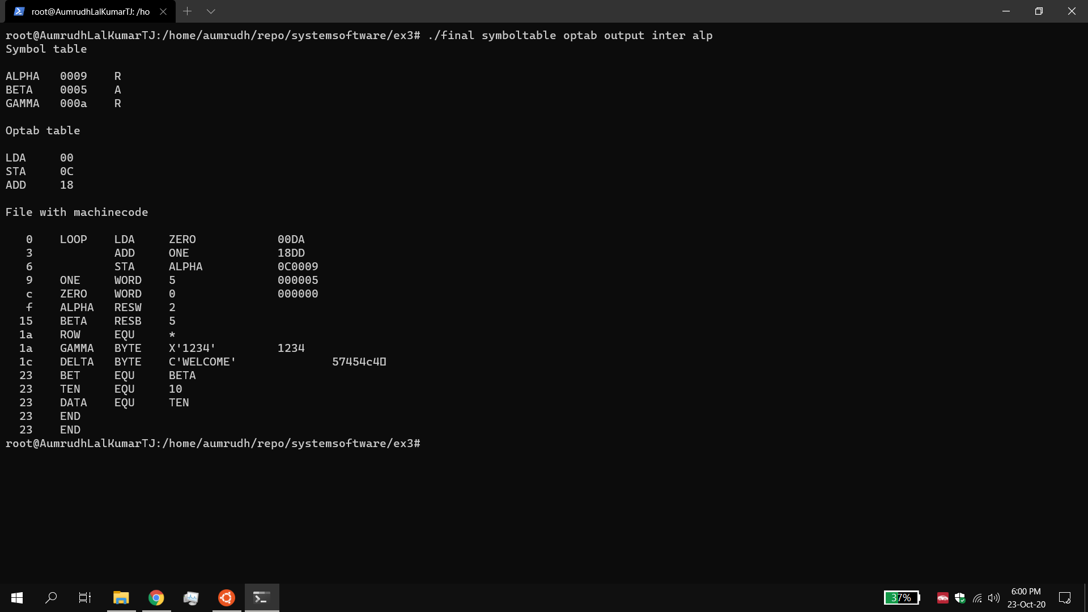

### Result:

The object code is generated for each line and the object program was generated successfully.